1. When you will open the website, you will be seeing Login page, When you first time open the website you were not logged in right, so you can see Register, click on that.

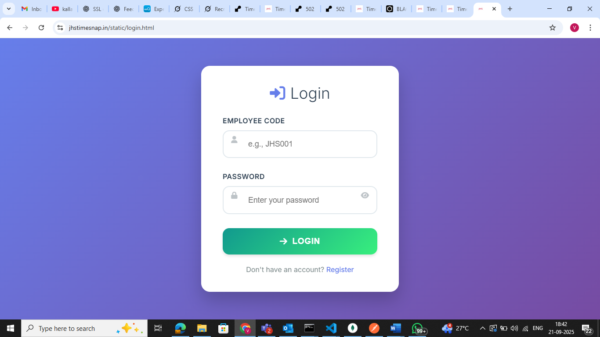

1. Then you can see the register page, Enter your Employee code (reminder: employee code should be right, otherwise you will not able to login). And also you can see there are conditions of creating password, which should be minimum 8 characters, 1 uppercase, while entering password make sure all lines should be green. Also both password and confirm password should be same.

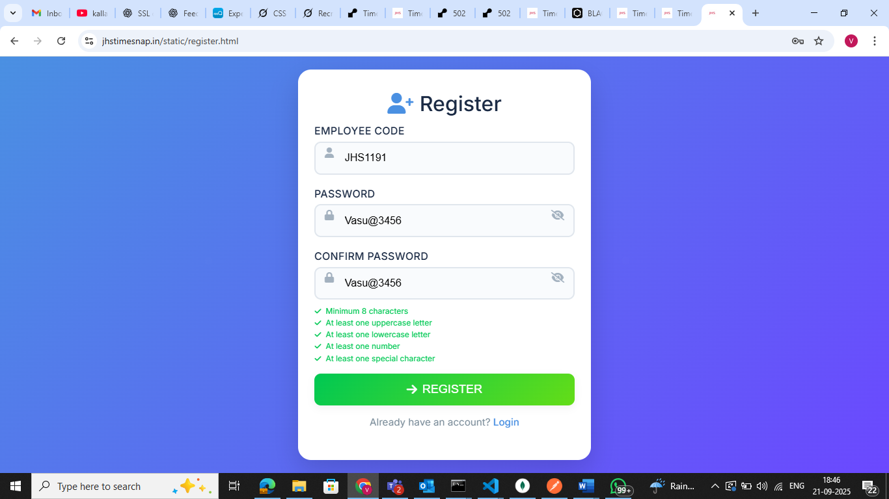

1. After clicking on register, you will be registered user and you will be redirecting again to login page, to add details and then login with credentials you added.

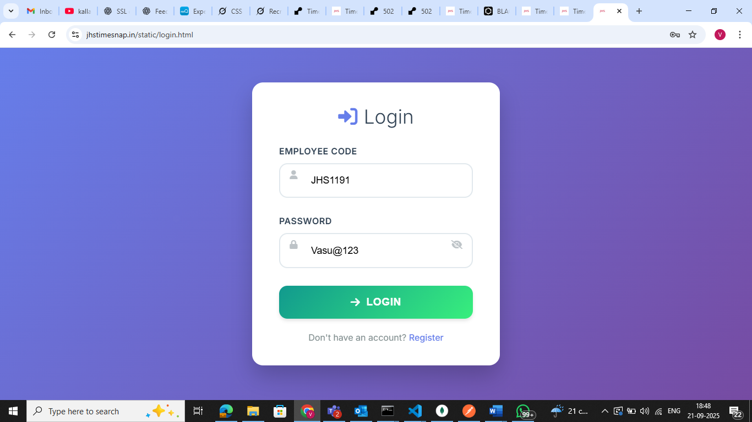

1. Then, you will be redirecting to dashboard

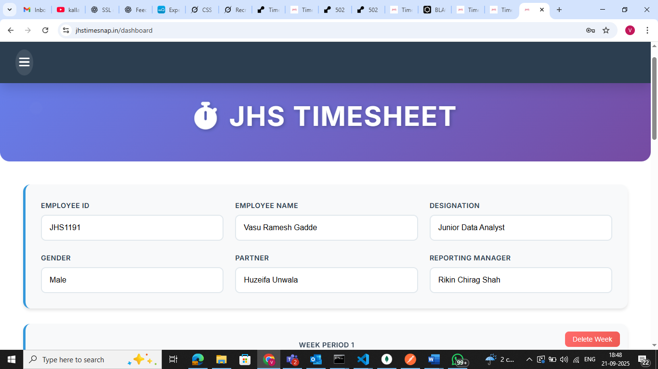

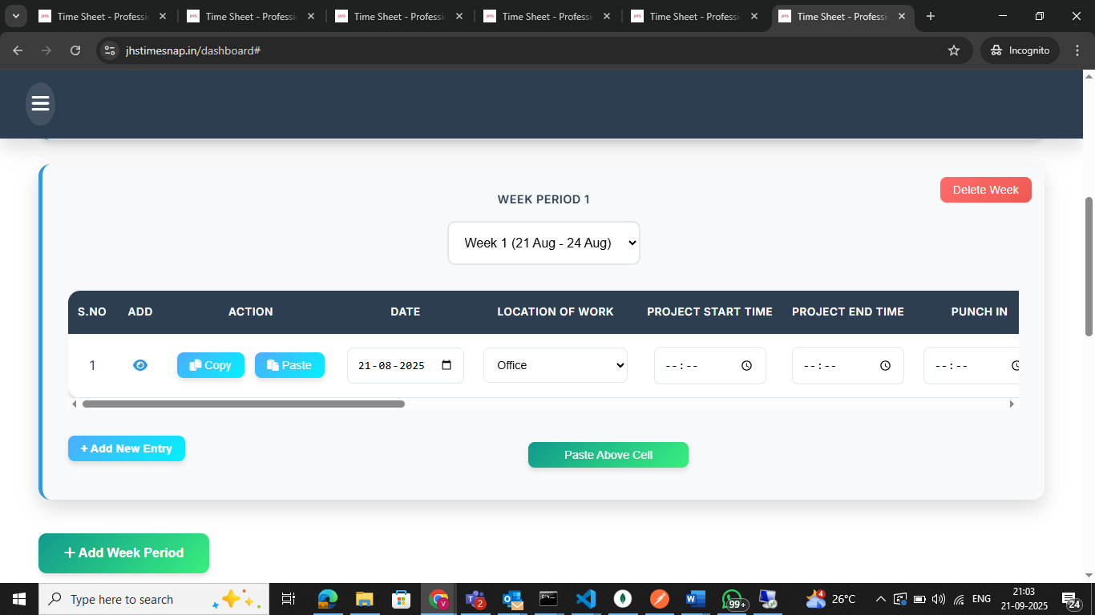

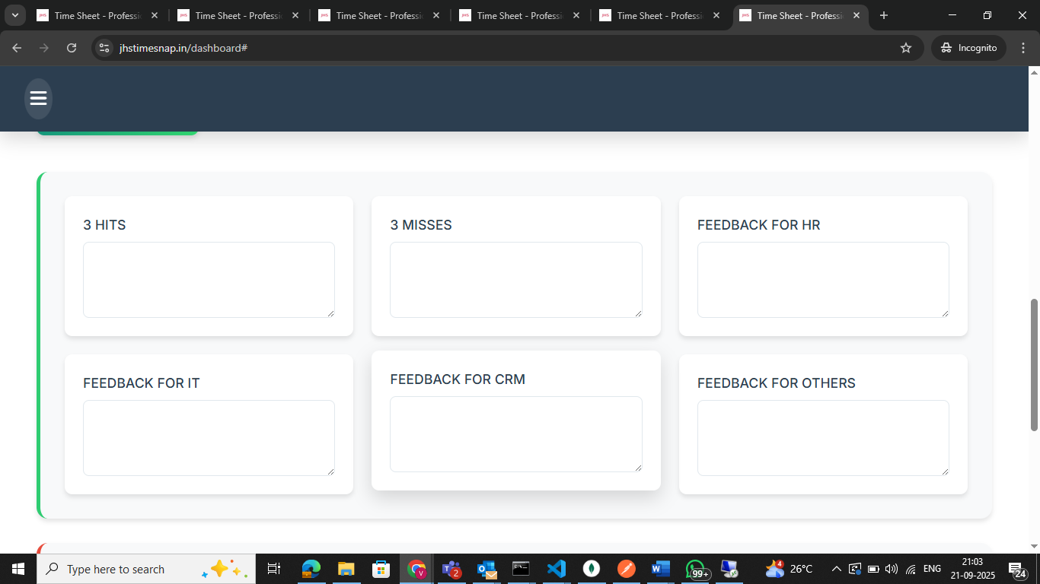

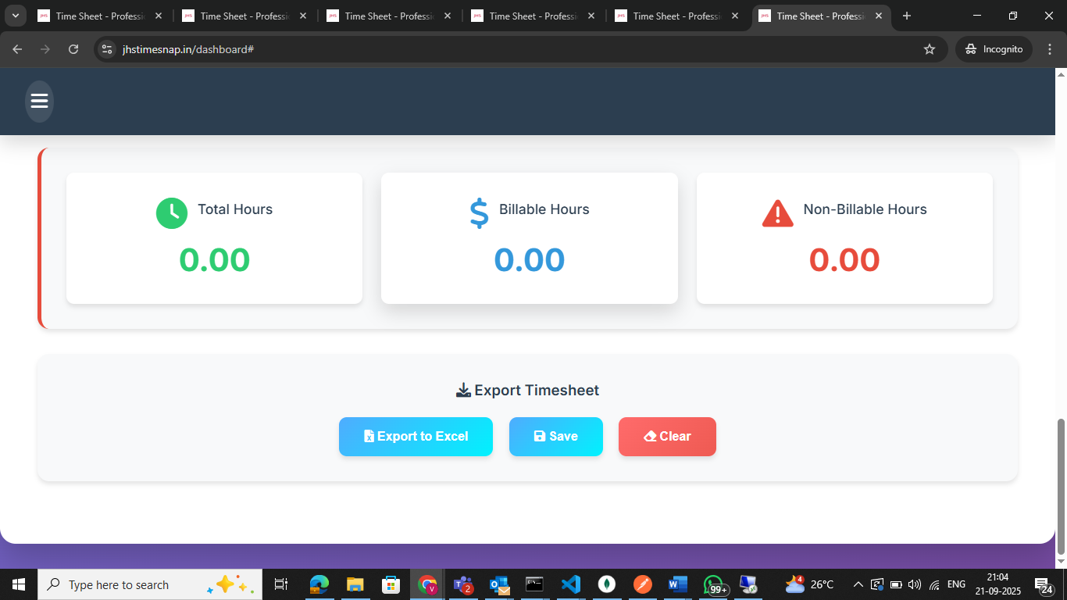

You can see all the above details in dashboard.

1. For filling timesheet, you can see below image, you can see select the week period, between 5 weeks from 21 Aug to 20 Sep as we follow 21 to 20 cycle, so I have divided in weeks, you can select a week.

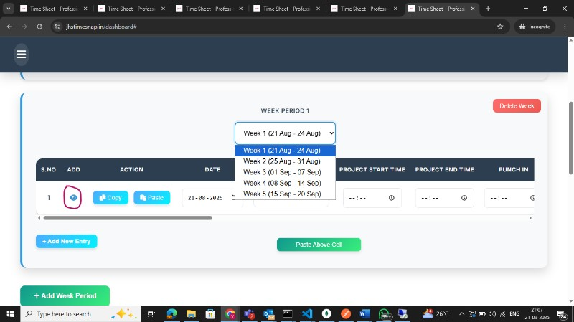

1. After selecting week, to fill the timesheet, click on eye icon, which I have marked with ink, after clicking on that you will get a modal or pop up like below and start filling out the timesheet, select the date, location of work, punch in and out and project start and endtime, and all. Also while adding client, if a client name is not mentioned in clients dropdown, then there is an option in last “Type here”, by clicking on that you can Type your client names and add the project details and project codes. After adding all the details, there is a button below “Add”, after clicking on that the details will get add in the row

